Rocky Mountain High
September 15-22, 2019
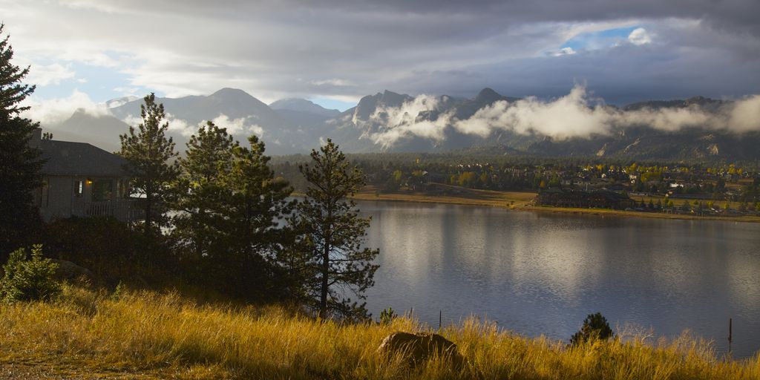

My husband Rein and I have been exploring Rocky Mountain National Park, in Estes Park Colorado for over 35 years. We thought it was time to share its beauty and grandeur with others who desire to feel a Sacred Earth connection to this popular National Park. Mid-September is the perfect time to visit as the crowds have left and the Aspen are turning golden, and the Elk are moving down into the valleys to rut.
This Nature Travel Adventure will be a combination of Forest Therapy, Meditation, Relaxation, and Guided Hiking at your leisure. We will be staying in a true Colorado Lodge with amazing views of Estes Lake and the Front Range beyond. Estes Park is an easy location to access from Denver International Airport.
Estes Park Shuttle Service offers round trip service for $85.00 directly into town several times a day. You can even be dropped off at our lodges front door!
Trained as a professional Chef, Rein will be cooking amazing and healthy meals for us each day, and will also be our driver for our 14 passenger Touring Van. All of your meals will be paid for as well as all entrance fees into the park. You will have an opportunity to purchase specialty foods on your own.
Accommodations at our 5 bedroom Lodge are sharing a Queen, King, or Double Bunk Bedroom with one other person. Those who register first will have first choice. Every effort will be made to pair you up with a roommate if you need one.
A Deposit of $500 will hold your reservation with the Final payment to be due June 19, 2019. Please make you payment through PayPal (fee of 2.9%) from my website store or mail a check to: Eco-Balance or Minnie Kansman 4287 Lyons Road , Lyons Mi. 48851

